* **Cause Four: The Financial Crisis**
* *The war debt incurred by the French in the 18th century was greatly swollen for what reason?*
* *Who tried to fix the problem of TAXES?*
* **Charles de Calonne:**
  + **Tax \_\_\_\_\_\_\_\_\_\_\_\_\_\_\_\_\_\_\_\_\_**
  + **Lighten \_\_\_\_\_\_\_\_\_\_\_\_\_\_\_\_\_\_**
  + **Representative Provincial \_\_\_\_\_\_\_\_\_\_\_\_\_\_\_.**
* **Assembly of Notables:**

Louis XVI hires \_\_\_\_\_\_\_\_\_\_\_\_\_\_\_\_\_\_\_\_\_\_\_\_\_\_\_\_\_

* Calls for \_\_\_\_\_\_\_\_\_\_\_\_\_\_\_\_
* Rejected =
* Dismisses Parlements
  + \_\_\_\_\_\_\_\_\_\_\_\_\_\_\_\_ brings government to a standstill
* 7/5/1788: Lousi XVI agrees on Estates General Meeting
  + Directs estates:

DEADLOCK

Calonne Fired

## STAGES of The REVOLUTION

* Stage 1: Estates General
  + *What is the nobility’s plan?*
  + *Explain how the nobililty give up some privileges and get more control of the government.*
  + *What is the reaction of the Third Estate to all of these changes?*
* *January 1789: Abbe Sieyes publishes his pamphlet: “What is the Third Estate?”*

**The Estates General Convenes: 1789**



|  |
| --- |
|  |
| The Oath of the Tennis Court (June 20, 1789) |
| tennis_oath.jpg (8340 bytes)BAILLY: I do not need to tell you in what a grievous situation the Assembly finds itself; I propose that we deliberate on what action to take under such tumultuous circumstances.  M. Mounier offers an opinion, seconded by Messieurs Target, Chapelier, and Barnave; he points out how strange it is that the hall of the Estates General should be occupied by armed men; that no other locale has been offered to the National Assembly; that its president was not forewarned by other means than letters from the Marquis de Brezé, and the national representatives by public posters alone; that, finally, they were obliged to meet in the Tennis Court of Old Versailles street, so as not to interrupt their work; that wounded in their rights and heir dignity, warned of the intensity of intrigue and determination with which the king is pushed to disastrous measures, the representatives of the nation bind themselves to the public good and the interests of the fatherland with a solemn oath.  This proposal is approved by unanimous applause.  The Assembly quickly decrees the following:  The National Assembly, considering that it has been called to establish the constitution of the realm, to bring about the regeneration of public order, and to maintain the true principles of monarchy; nothing may prevent it from continuing its deliberations in any place it is forced to establish itself; and, finally,  the National Assembly exists wherever its members are gathered.  Decrees that all members of this assembly immediately take a solemn oath never to separate, and to reassemble wherever circumstances require, until the constitution of the realm is established and fixed upon solid foundations; and that said oath having been sworn, all members and each one individually confirm this unwavering resolution with his signature.  Bailly: I demand that the secretaries and I swear the oath first; which they do immediately according to the following formula:  We swear never to separate ourselves from the National Assembly, and to reassemble wherever circumstances require, until the constitution of the realm is drawn up and fixed upon solid foundations.  All the members swear the same oath between the hands of the president.  [Source: *Gazette Nationale, ou Le Monituer universel*, trans. Laura Mason in Laura Mason and Tracey Rizzo, eds., *The French Revolution: A Document Collection* (New York: Houghton Mifflin, 1999), pp. 60-61.] |

* **National Assembly (3rd Estate)**

**…** Now what?

* Financial Crisis
  + The economic crisis leads to \_\_\_\_\_\_\_\_\_\_\_\_\_\_\_\_\_\_\_\_\_\_\_\_\_\_\_\_\_\_\_\_\_\_\_\_\_\_\_\_\_\_\_\_\_\_\_\_\_\_\_\_\_.
  + Rumor:
  + *Whose troops did they think the king was going to use to fight against them?*

Fear “Noble organized” vagrants and troops, so \_\_\_\_\_\_\_\_\_\_\_\_\_\_\_\_\_\_\_\_\_\_\_\_\_\_\_\_\_\_\_\_\_.

* **The Fall of the Bastille: 7/14/1789**

**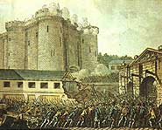**

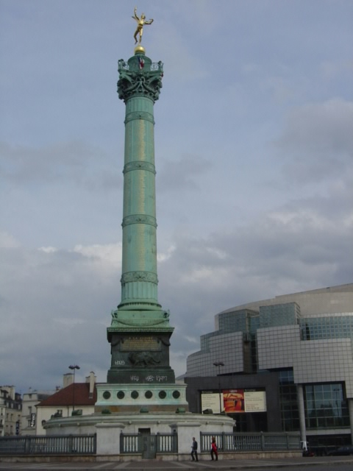

* **The Great Fear: July 20-August 5, 1789**

Describe the events:

# THE OFFICIAL: Stage 2 – National Assembly

* + **NATIONAL ASSEMBLY REFORMS**
    - **August 4, 1789 -** Why is this night so memorable?
    - **August 26, 1789 :** Declaration of the Rights of Man and Citizen

Meanwhile…

* Women’s Rights:
  + Olympes de Gouges writes *The Rights of Women* – followed by Mary Wollstonecraft in 1792 :

<http://www.pinn.net/~sunshine/book-sum/gouges.html> - please visit this site to read her version of the Rights of Man (and Women)

* October 5-6, 1789: Parisian Women storm Versailles

**Extremist Clubs begin to form such as: \_\_\_\_\_\_\_\_\_\_\_\_\_\_\_\_\_, who were the most advanced members of the assembly.**

* The “October Days” (1789) -> What do they force the king and his family to do?

# Stage 3: Legislative Assembly (also known as\_\_\_\_\_\_\_\_\_\_\_\_\_\_\_\_\_\_\_\_\_\_\_\_\_)

* **National Assembly -> Constituent Assembly: October 1789-September 1791**
  + CA is ruling the country and writing a Constitution!
    - Characteristics:

Result

**June, 1791:** The King attempts to flee the country, but he is caught in \_\_\_\_\_\_\_\_\_\_\_\_\_\_\_\_\_\_\_\_\_\_\_\_\_\_\_\_.

***Who does it alienate?***

**Constituent Assembly Reforms:**

**Effects of Religious Reforms:**

*What happens in September of 1791?*